

Year 7 Transition 1 – ICT Task 3

Using Equipment Safely

Learning Intention:

Success Criteria:

Use the five steps to research and filter information (clarify, search, investigate, evaluate, and cite) to complete this ICT task.

The Bunsen burner

One of the simple scientific equipment you will use in your experiments is the Bunsen burner. It is used to burn a controlled amount of gas to produce heat as we need it. The collar controls the amount of air entering the burner and this determines the heat of the flame produced.

- Research who Bunsen was and what he had to do with the burner named after him.
Keywords | Notes

- Describe the different flames in the diagram below.

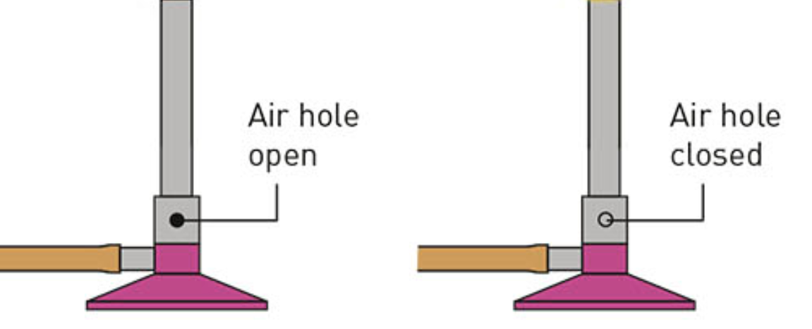

Air hole open
Keywords | Notes
Air hole closed
Keywords | Notes

- What does the safety flame look like and why is it called a safety flame?

Keywords | Notes
 | 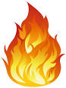

- Describe three ways in which the heating flame is different from the safety flame.

Keywords | Notes

- Explain what the heat does to gauze, and why we use the gauze here.

Keywords | Notes
 | 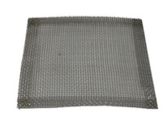

Disposing of chemicals

Australia is the driest continent on Earth – can we afford to waste water? Any chemicals down the drain in a laboratory will add to the environmental problems. Water Corporation (local authority) only allow minimal amounts of some chemicals to be washed down the drain with lots of water to dilute them. Teachers and students should dispose of chemicals thoughtfully rather than ‘the easy way’ – down the sink.

This is a list of heavy metals you are likely to use in your experiments.

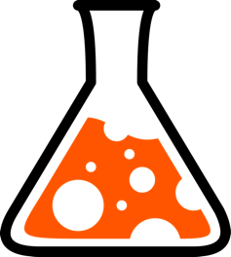
Copper
Nickel
Zinc
Silver
Lead
Cobalt
Barium

- How should you dispose each of the following chemicals?

Chemical | How to dispose of and explain why?
Copper sulfate solution

Hydrochloric acid solution

Ammonia solution

Sodium chloride solution

Nickel chloride solution

Solid barium carbonate

Sodium hydroxide solution

Potassium nitrate solution

Extension activities

- Construct a sign using 3D Paint that warns people that Bunsen burners are hot. Your sign should be in three colours and use no words.

- Research what to do if you come across someone who has burnt themselves.

- Research what the fire blanket is, what material it is made of and how to use it.

- Cubirocks estimate and measure volume. Click on the link below to play the game.

http://www.scootle.edu.au/ec/viewing/L162/index.html

